Setting up wind animation parameters.

- Put the wind into “Force Mode” and set it's value to 1.0 ( the maximum wind value )
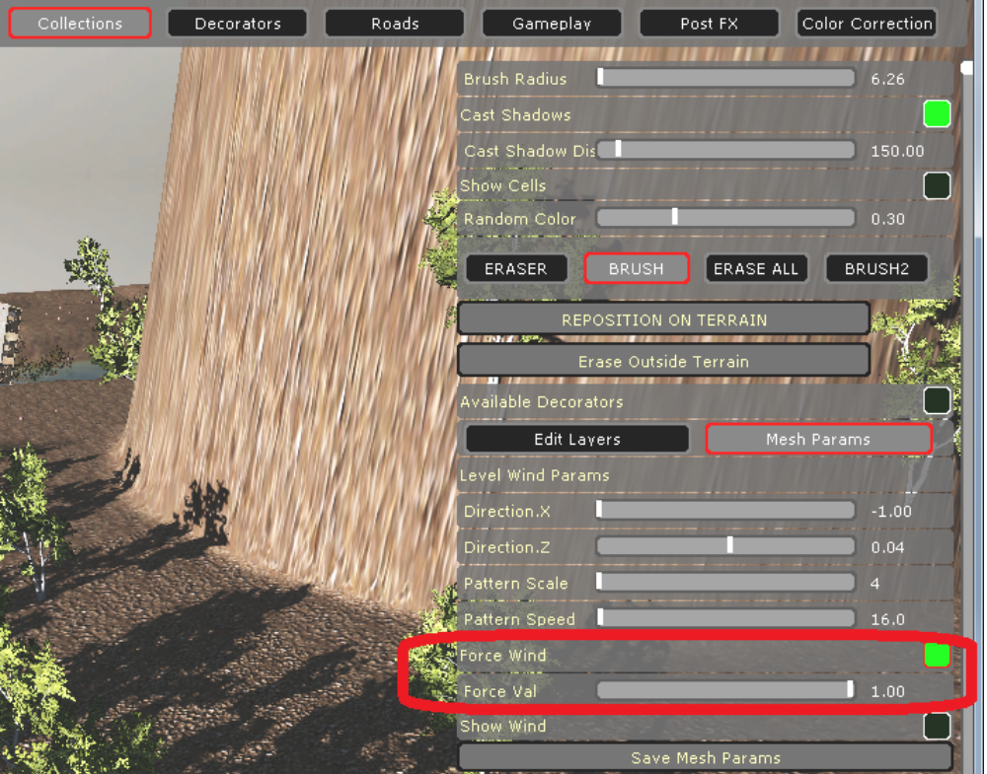

- Setup mesh animation parameters at full wind strength

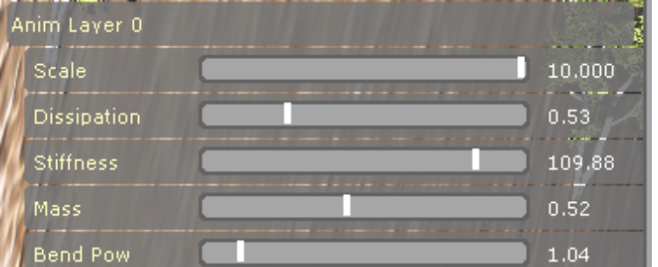
Aim Layer 0 is a layer for stem and runs a physical simulation of tree bending.

Scale – sets up the maximum bending of the tree
Dissipation – defines how tree movement energy gets dissipated. The more the value, the faster the tree stem will slow down its movement.
Stiffness – defines the force with which the tree stem tries to restore itself to neutral position
Mass – defines the mass of the stem ( the more the mass, the less the tree stem gets accelerated )
Bend Pow – defines the curvature of the tree stem bending.

Anim Layer 1 is a layer for branches.
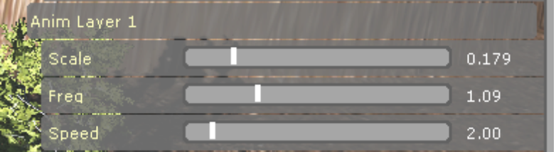
Scale - affects the amplitude of the branches animation.
Freq – affects the spatial frequency of the branch animation ( the bigger the number, the smaller the “waves” of the branches become )
Speed – affects the speed of the branches animation.

Anim Layer 2 is a layer for leaves

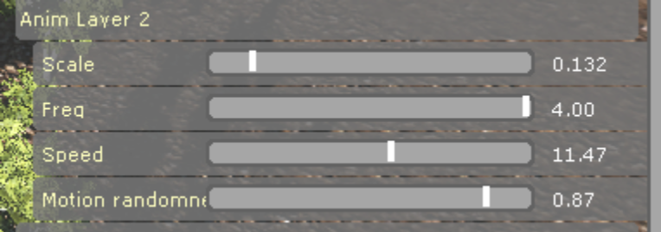
Scale, Freq and Speed function as in the animation layer 1.

Motion randomness - defines the randomness of leaves animation direction. In case of 0 value, movements of the leaves coincide with the wind direction. In case of 1 value, movements of the leaves are completely random.

- Move “Force Val” slider from 0 to 1 several times and adjust Anim Layer 0 parameters to make the stem react to the wind change naturaly.

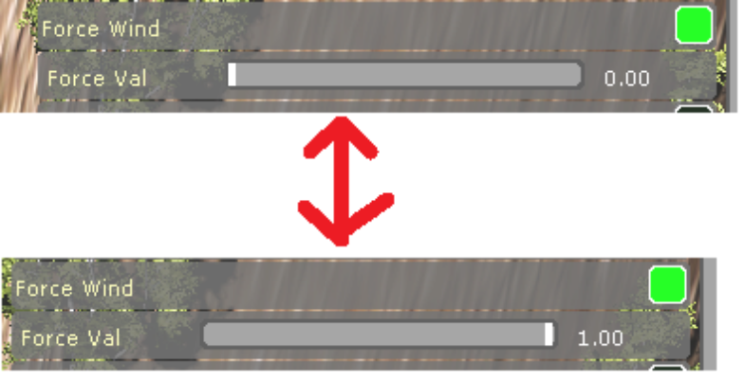
- Disable “Force Wind” and enable “Show Wind” to see how wind pattern affects the level:

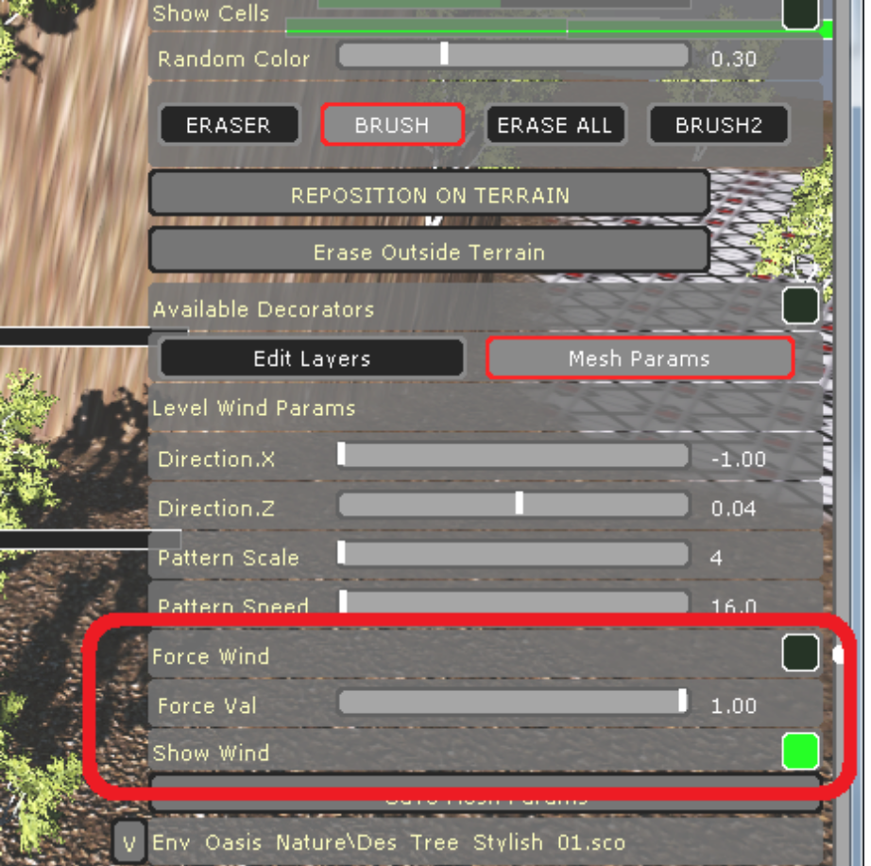

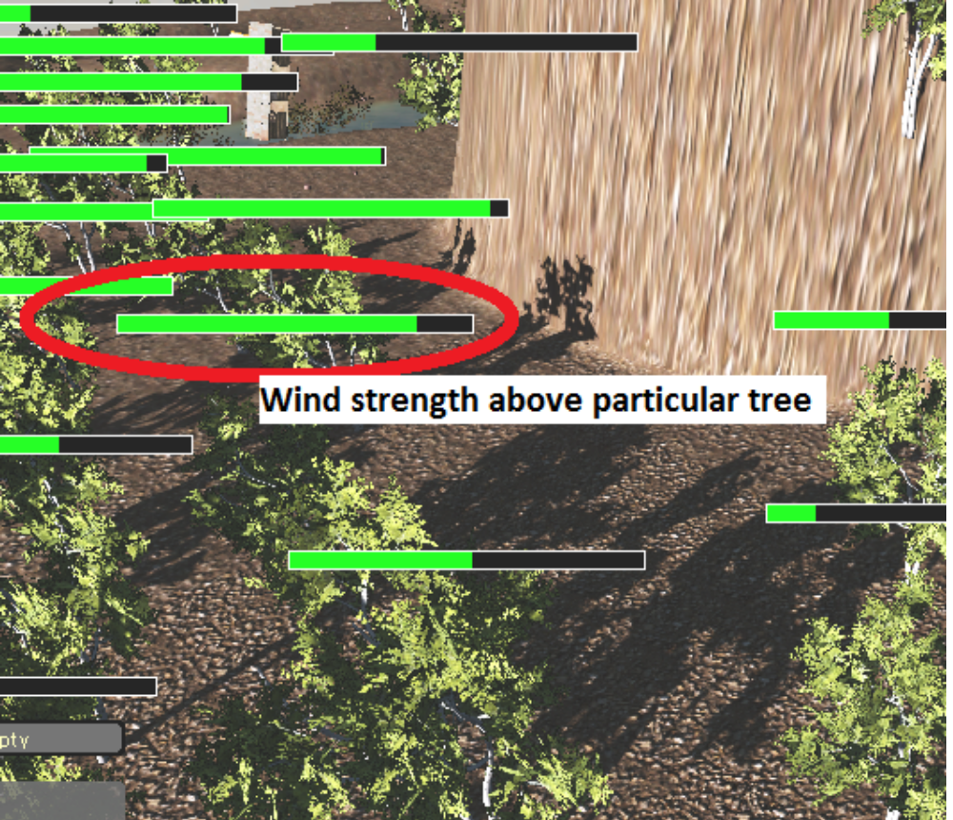
- Adjust level wind parameters while being in “Show Wind” mode.
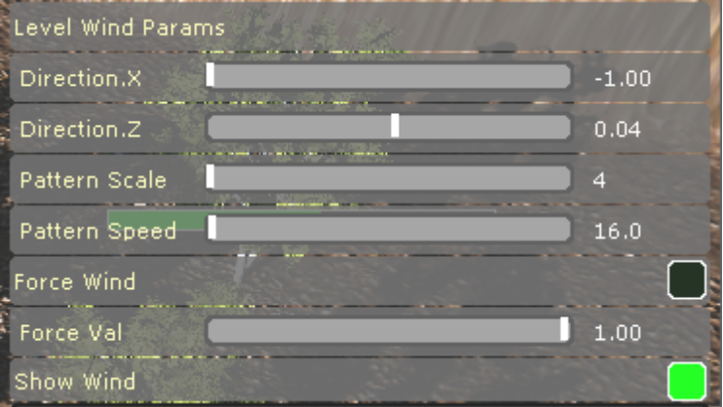
Directex.X, Direction.Z - setup level wind direction.
Pattern Scale - defines the scale of the noise texture, which adjusts wind speed at particular level spots. This texture is tiled over the level.
Pattern Speed – defines how fast the wind noise texture is scrolled over the level

